LITTLE BLUESTEM GRASS

*Schizachyrium scoparium.* Common name: Little Bluestem, Prairie Beardgrass, Prairie Beard Grass

Little Bluestem is a native ornamental grass with beautiful blue-green foliage.  Purplish bronze seed heads and yellow-orange leaves make for great fall interest in the landscape.  It is attractive planted in a mass and would make an excellent addition to a rain garden. It has drought resistance once established. It is well-adapted to southern climates as it tolerates high heat and humidity.

Little Bluestem is a perennial, warm-season grass. The leaves and stems frequently have a bluish cast in summer, while the fall color is a very warm copper that does not fade throughout winter. This grass is highly resistant to deer.

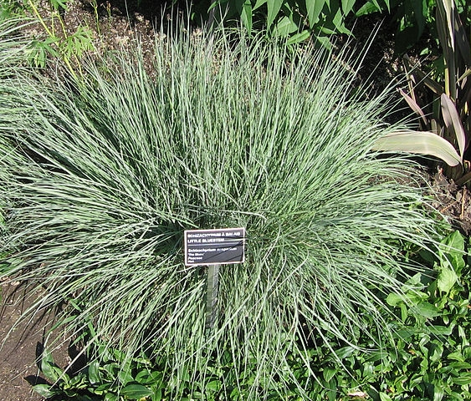**Wildlife Value**: Provides excellent cover year-round. This is a larval host plant that supports various skipper larvae and Common Wood-Nymph (Cercyonis pegala) which have one brood from late May to October. Adult Common Wood-Nymph butterflies feed on rotting fruit and flower nectar. Seeds are eaten by songbirds and small mammals.

**Exposure**: Full sun

**Soil:** dry to medium moisture, well drained, tolerates acidic, fertile, sand, and clay soil.

**Height**: 5 ft.

**Zones**: 3-9

**Habit**: Perennial

**Insects, Diseases, or Other Plant Problems**: This plant suffers from too much mulch near the crown.

**Care:** Cut back to the ground in early spring to promote new attractive growth. Fertilize established plants in spring.

For information about gardening or the Extension Master Gardener Volunteer Program of Pender County, contact Tiffanee Boone, Pender County Horticulture & Local Foods Agent at tiffanee_boone@ncsu.edu or 910-259-1235.

